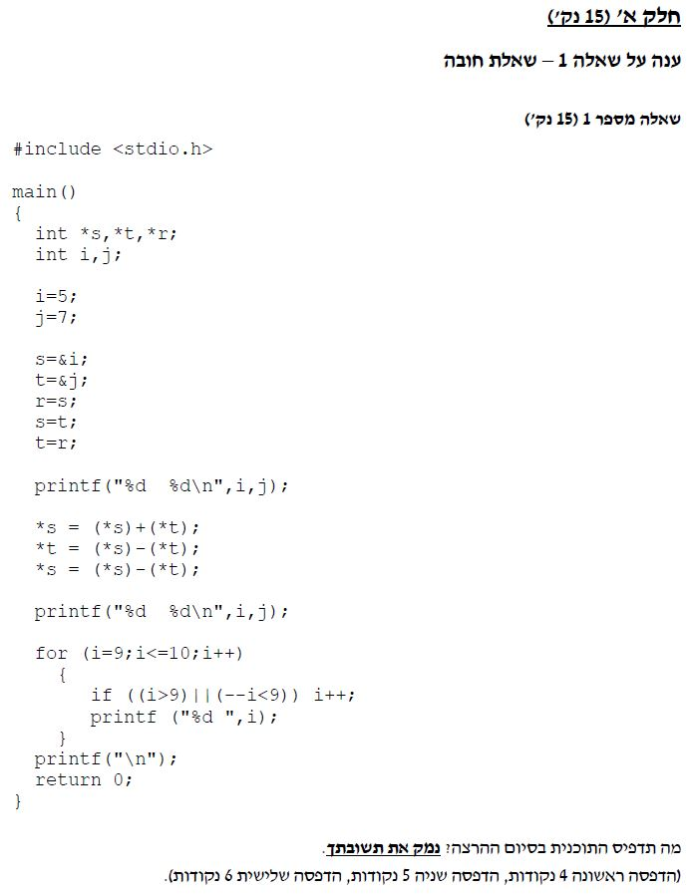

#include <stdio.h>

// Question 1:

void main()

{

int \*s, \*t, \*r;

int i, j;

i = 5;

j = 7;

s = &i; // s = i = 5

t = &j; // t = j = 7

r = s; // r = s = i = 5

s = t; // r = i = 5 , // s = t = j =7

t = r; // t = r = i = 5, // s = j = 7

printf("%d %d\n", i, j); // i=5, j=7

\*s = (\*s) + (\*t); // basic swipe

\*t = (\*s) - (\*t);

\*s = (\*s) - (\*t);

printf("%d %d\n", i, j); // i=7, j=5

for (i = 9; i <= 10; i++) // 2 rounds.

{

if ((i > 9) || (--i < 9)) //1. i=8. 2. 10

i++; //1. i=9 2. i=11

printf("%d ", i); //will print: 9,11

}

printf("\n");

getchar();

}